
Citypoint Room Hire
Visual Designs

Abdulkarim Naser
Mock exam
T-Level Computing

Contents
Site Map 2
Wireframe Designs 3
Algorithm Designs (Flowcharts) 10
Database Design 13
Data Dictionary 15
MVC System Data Dictionary 15
CityPoint Room Hire Data Dictionary 17

Site Map

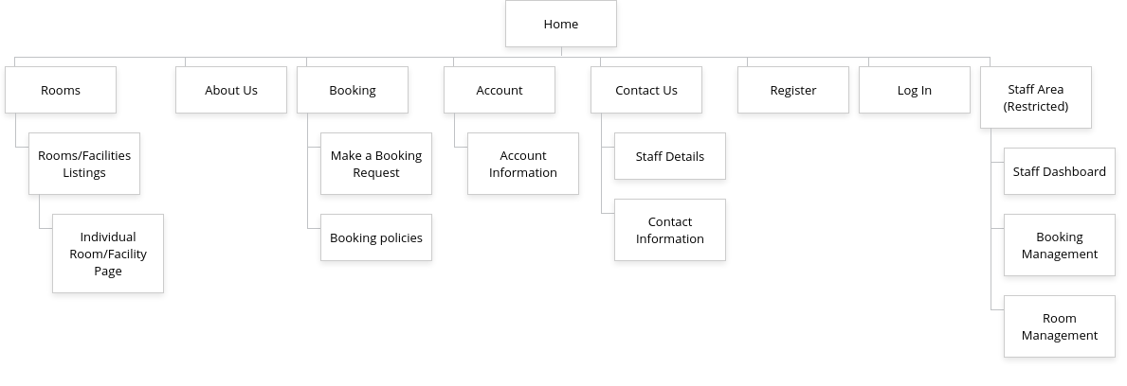

Wireframe Designs
  - Home Page
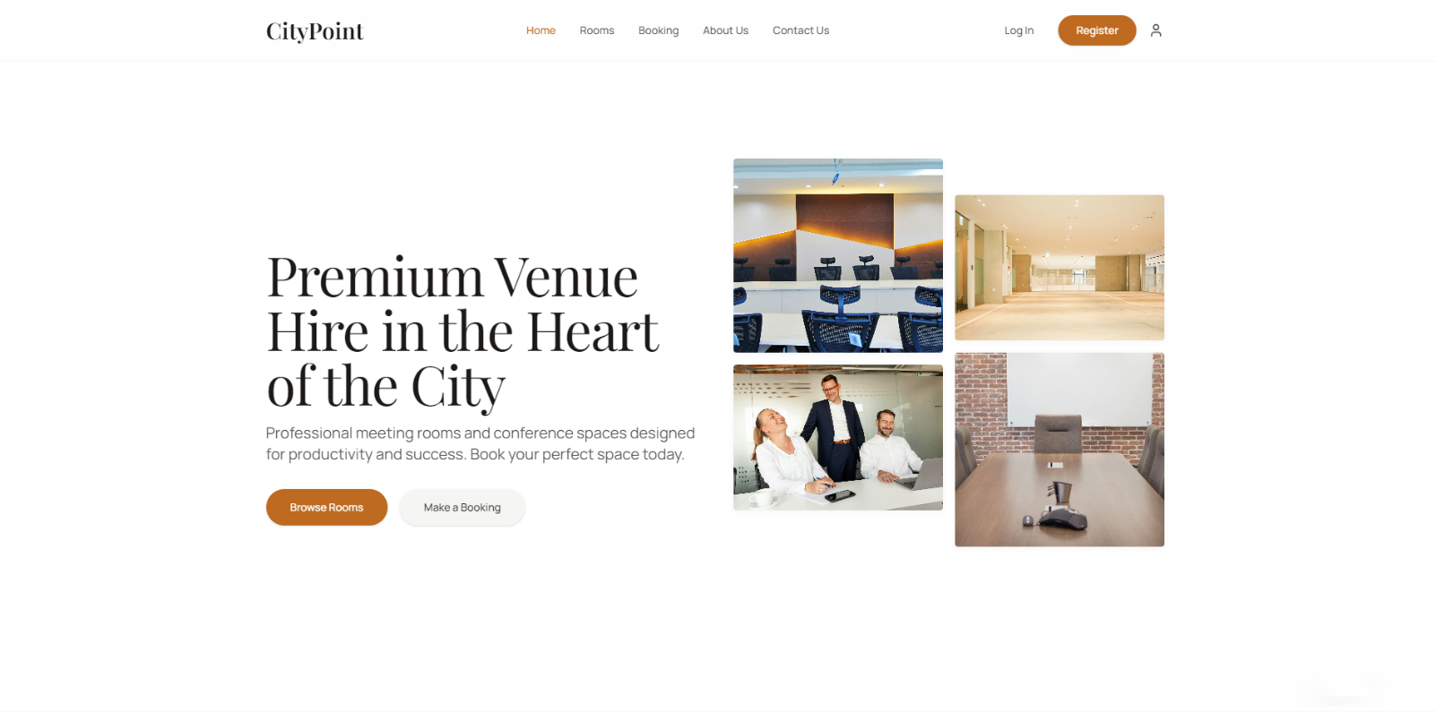
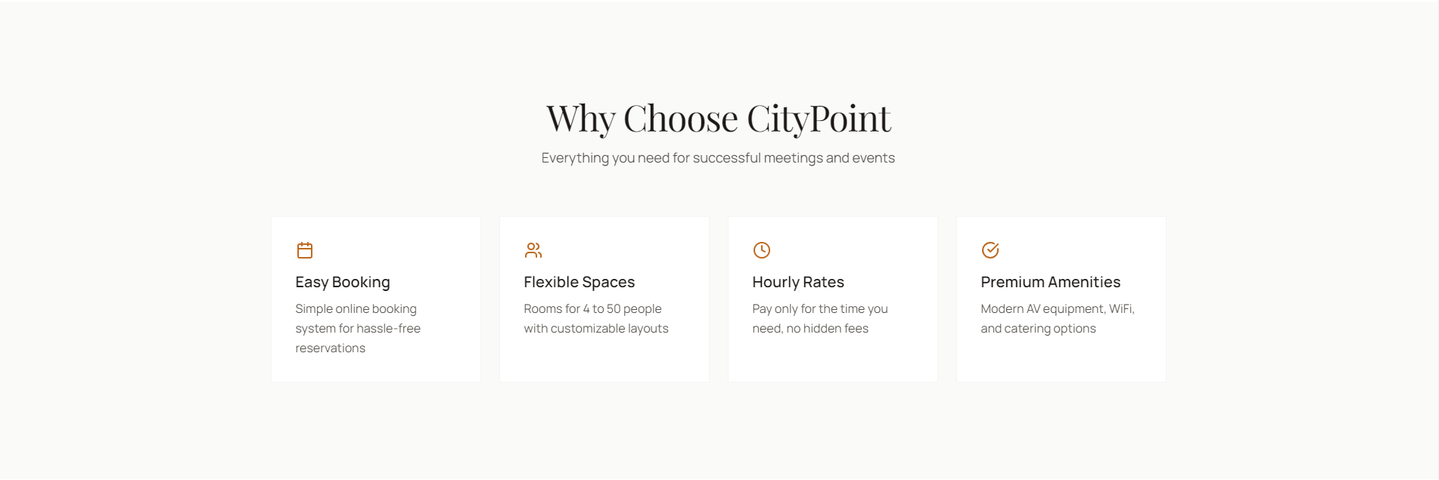
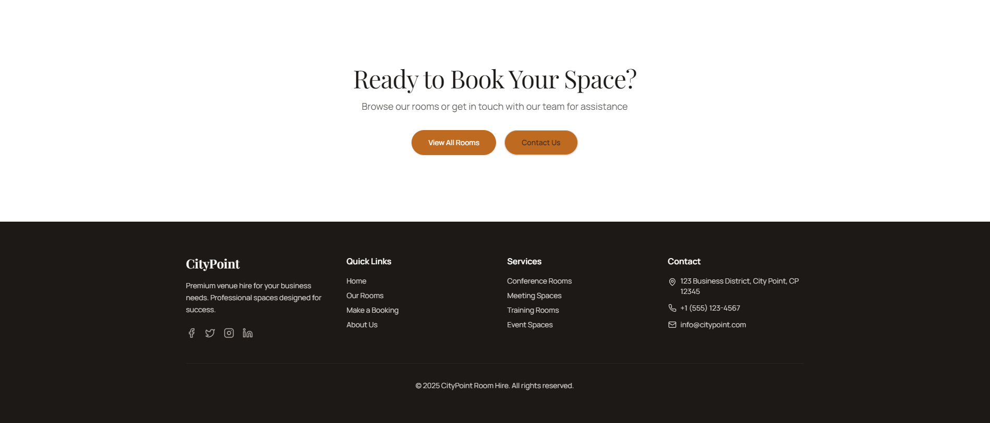
Througout all of my wireframes I have implemented a consistent structure and layout, I have used the same navbar in all of my pages in order for the user to have a seemless user experience so that they can navigate easily without any difficulties. The colours I have used on my navbar are white, a warm brown, and a dark charcoal colour for the text. I chose this neutral colour palette for the reason of making it easy for the user to see the key elements on the pages.
I have used the warm brown colour on all the important/relevant buttons on the page, the warm colour attracts the users to inspect the buttons and that helps them find all the pages they are interested in. This way it will help with the user engagement and their user experience.
The images that have been used are originally from a website called unsplash.com and in their website they have clearly stated that the images can be downloaded and used for free, for both commercial and non-commercial use purposes. So I am certain that using these images is legal and that I am following all the regulatory guidelines without violating any intellectual property or copyright laws.

The footer I have designed will also be used consistently throughout all the pages without any changes. It consists of a dark charcoal colour like the text of the website, this will help show the user that they have reached the end of the page when they see the dark colour compared to the light colous used on the other parts of the page. The footer include all the socials of the business, quick links for the users and simple contact information as well.
  - Rooms Page
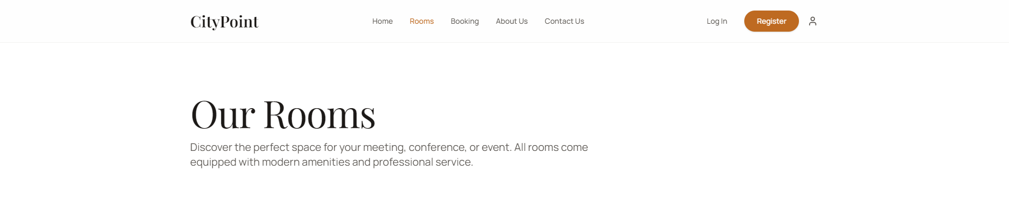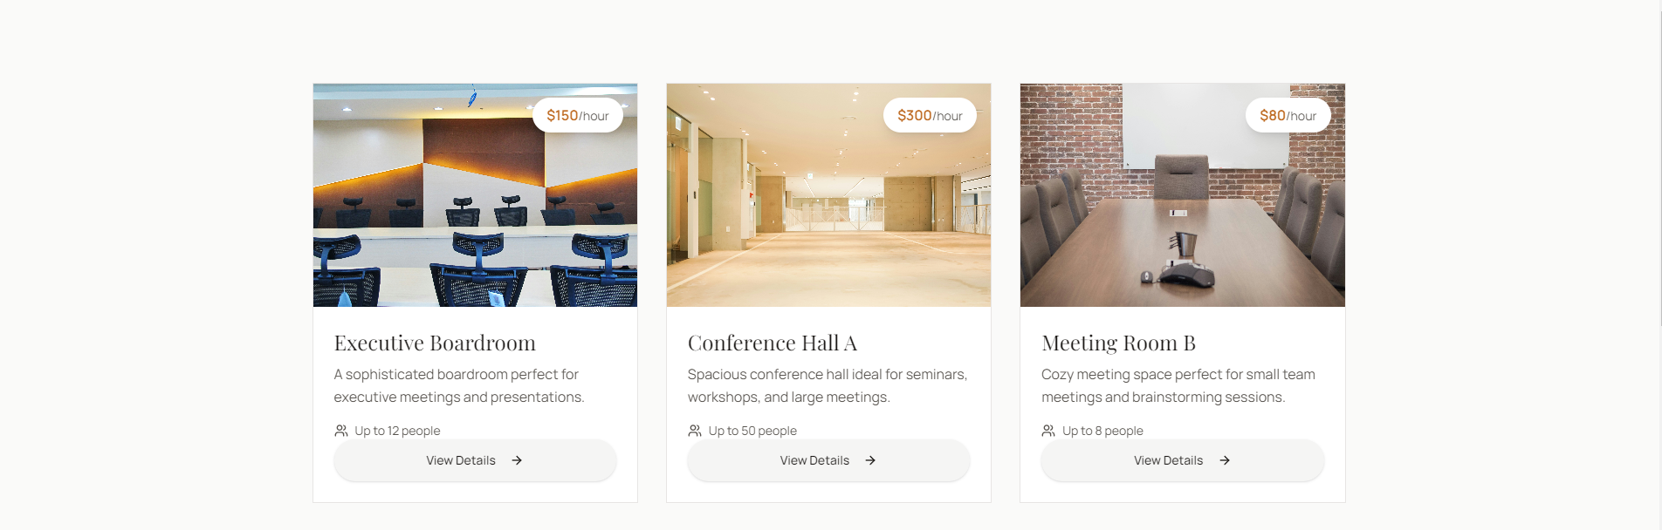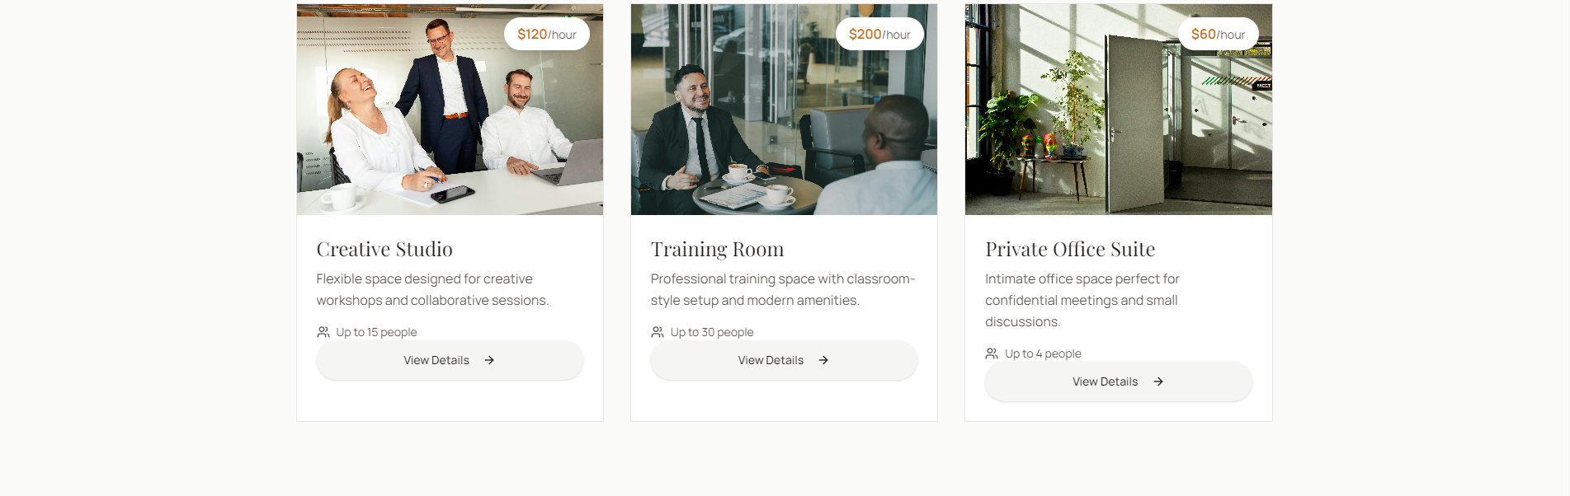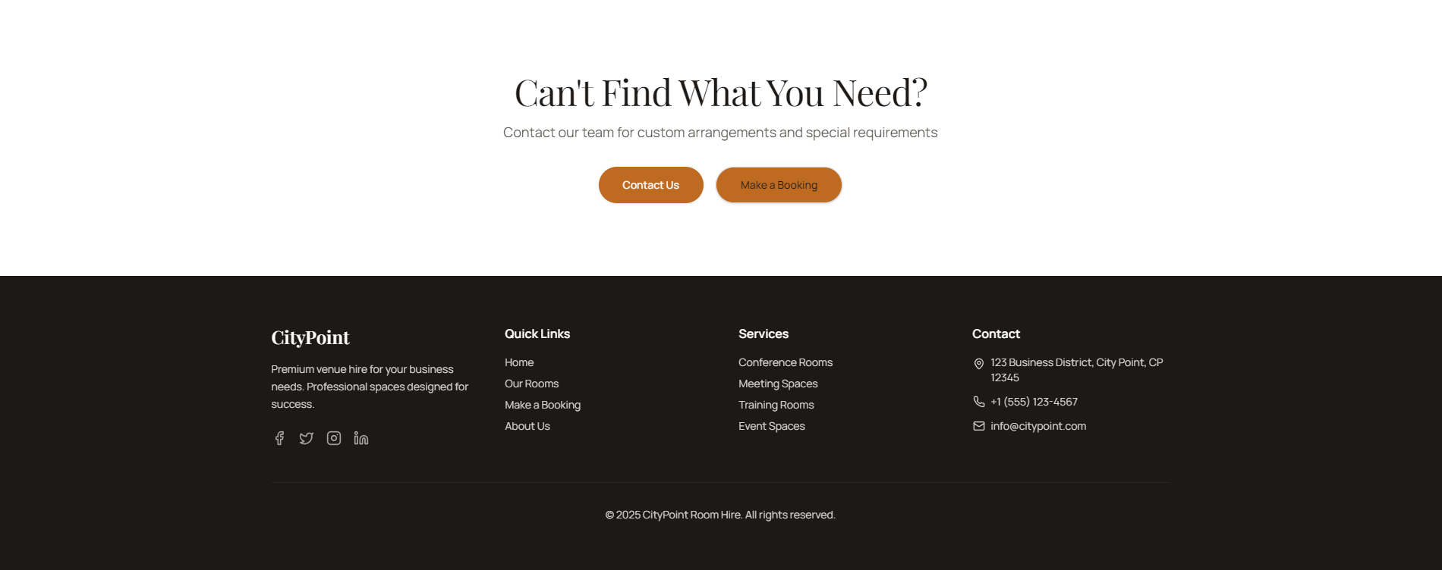

  - Booking Page
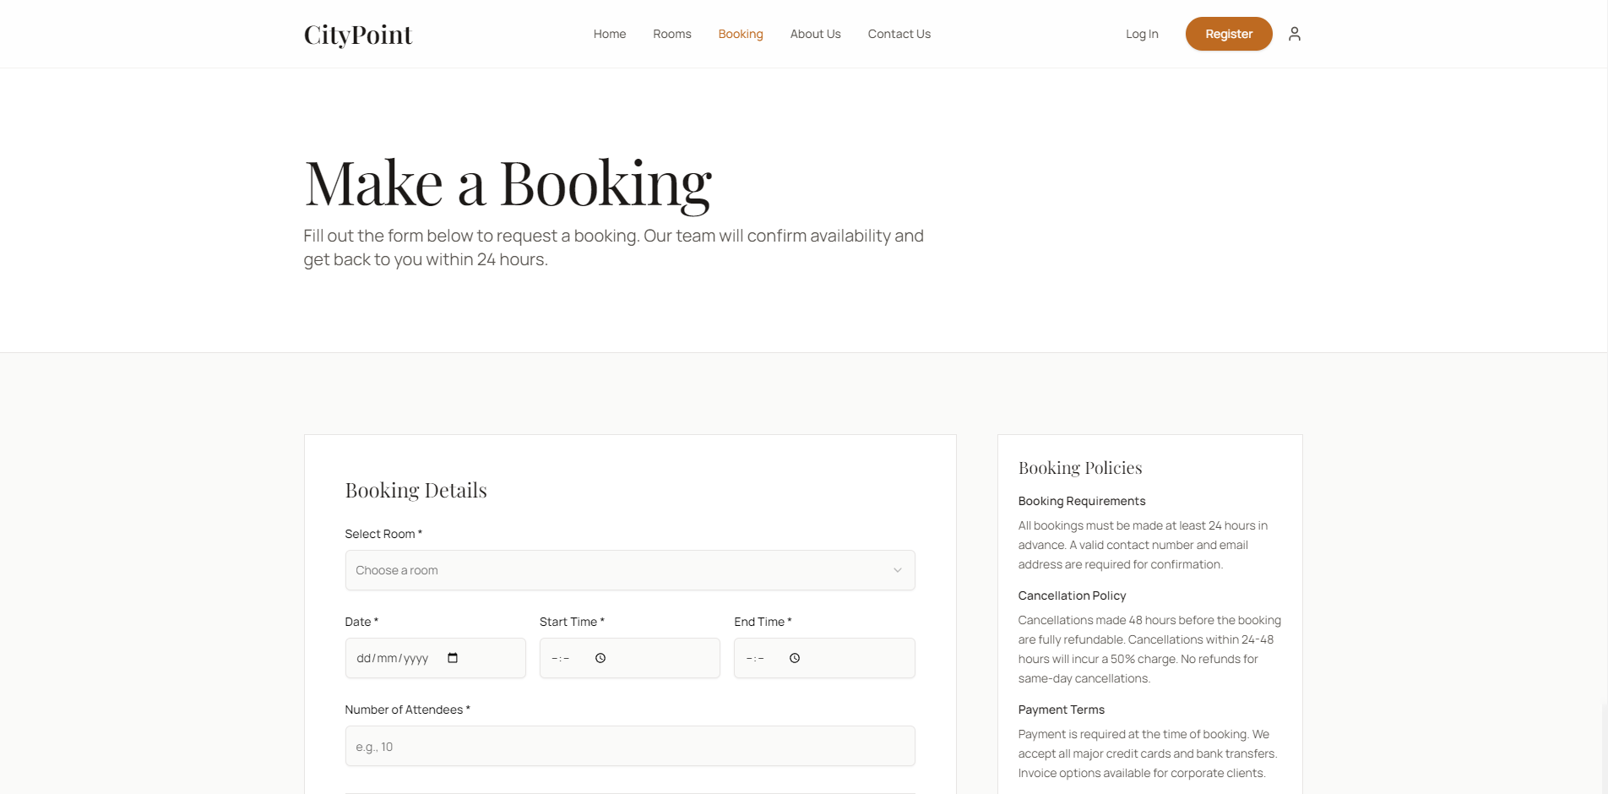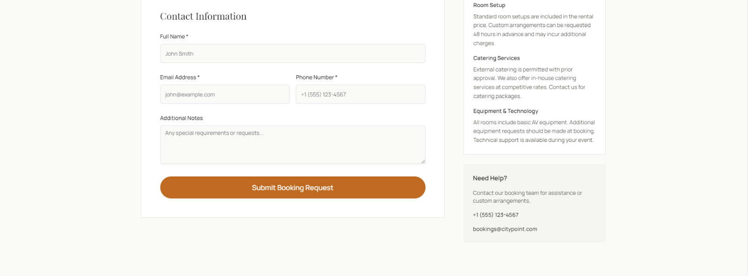

  - About Us Page
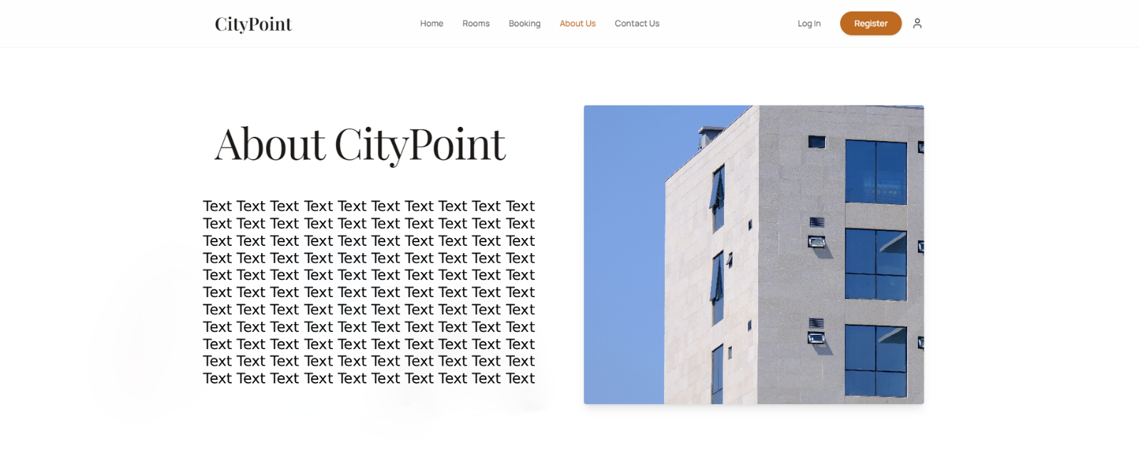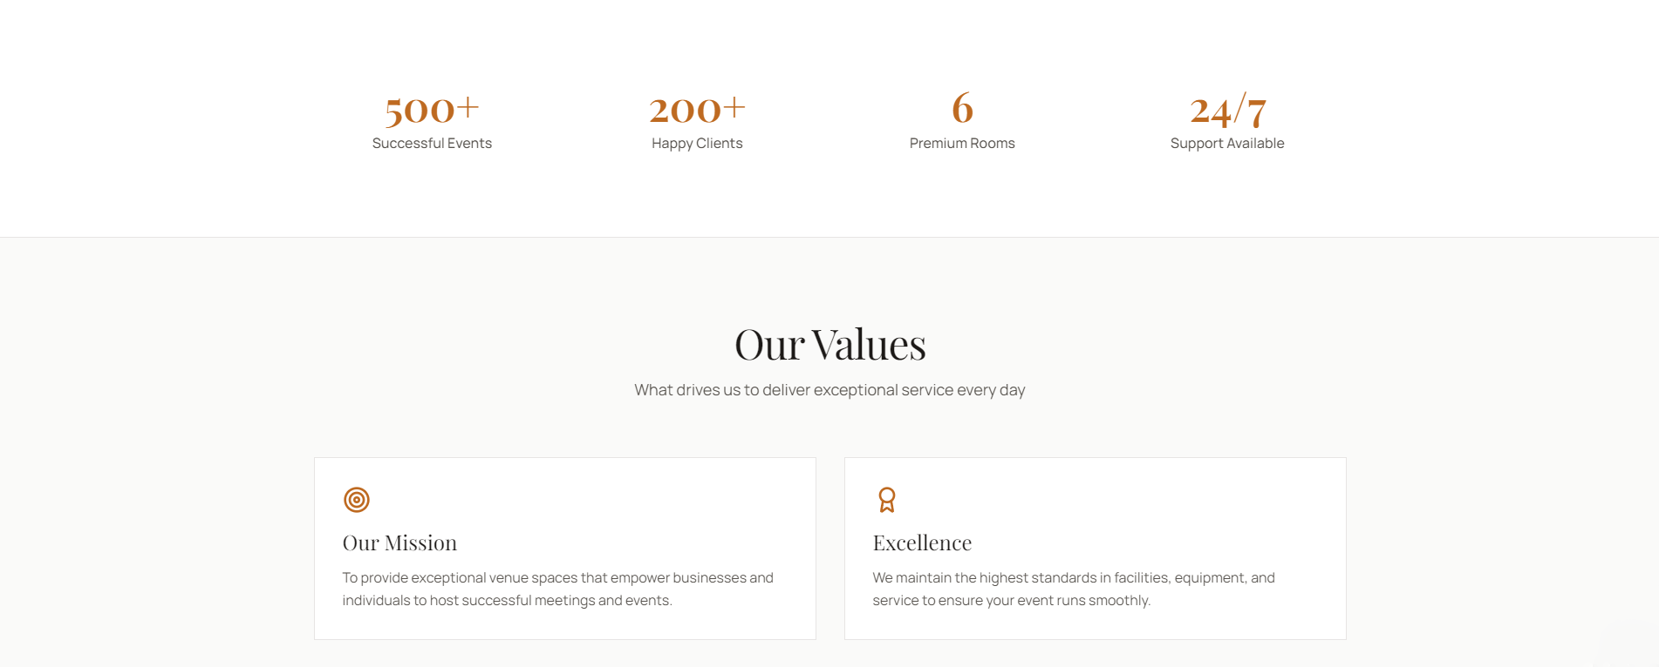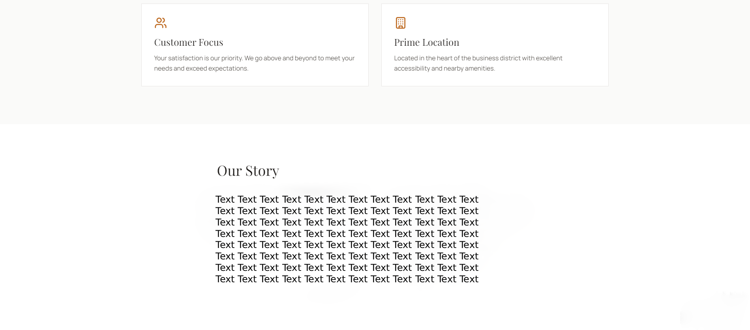

  - Contact Us Page
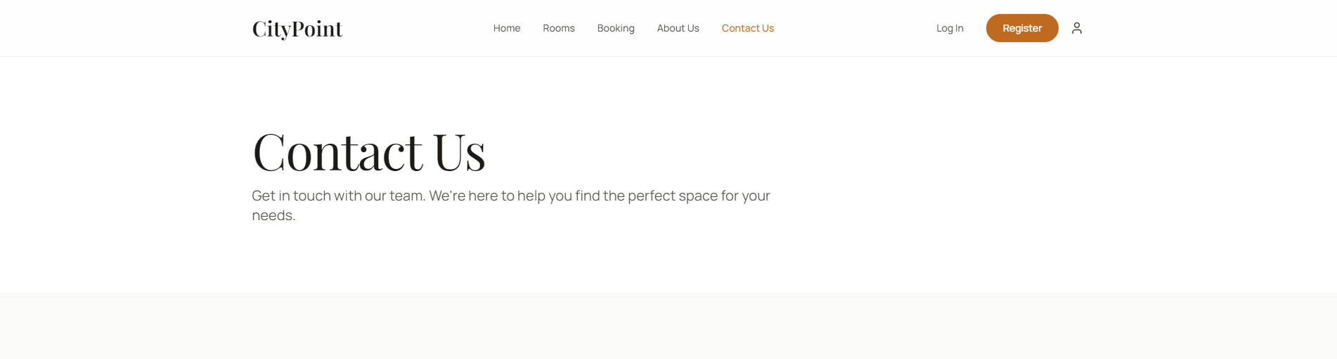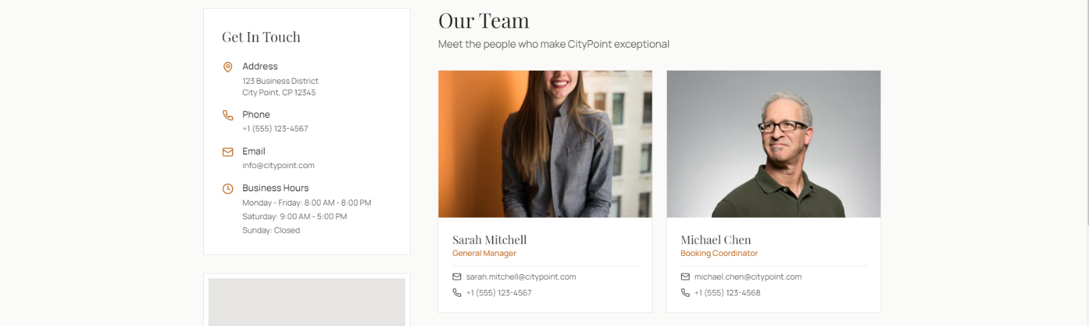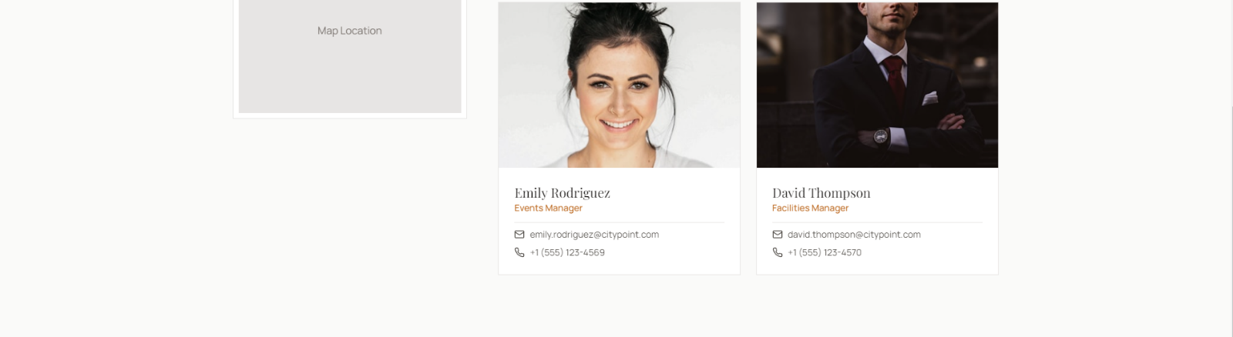

  - Register Page
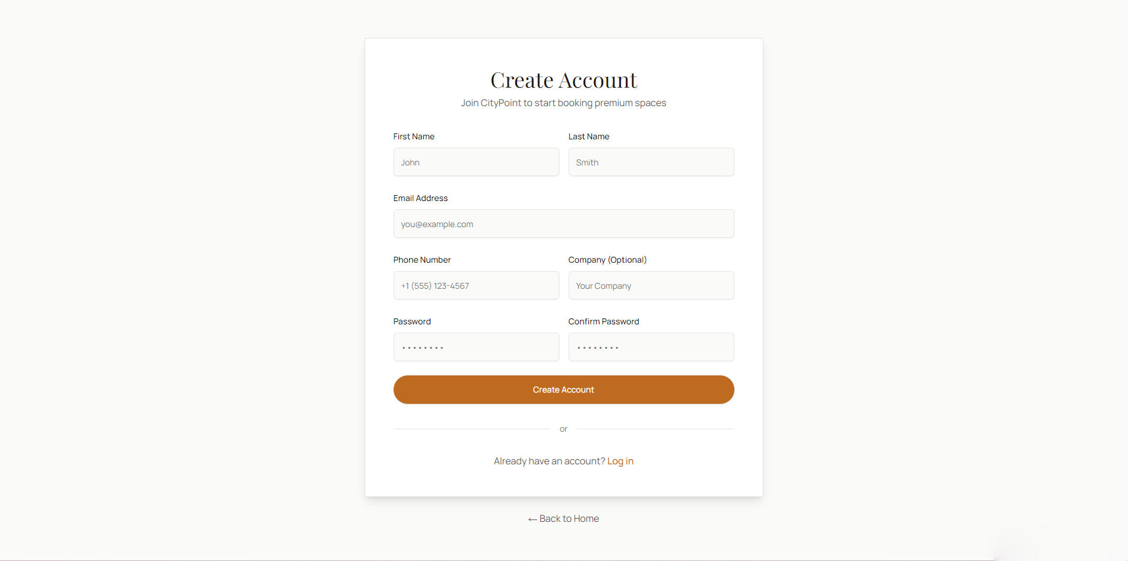

  - Log in Page
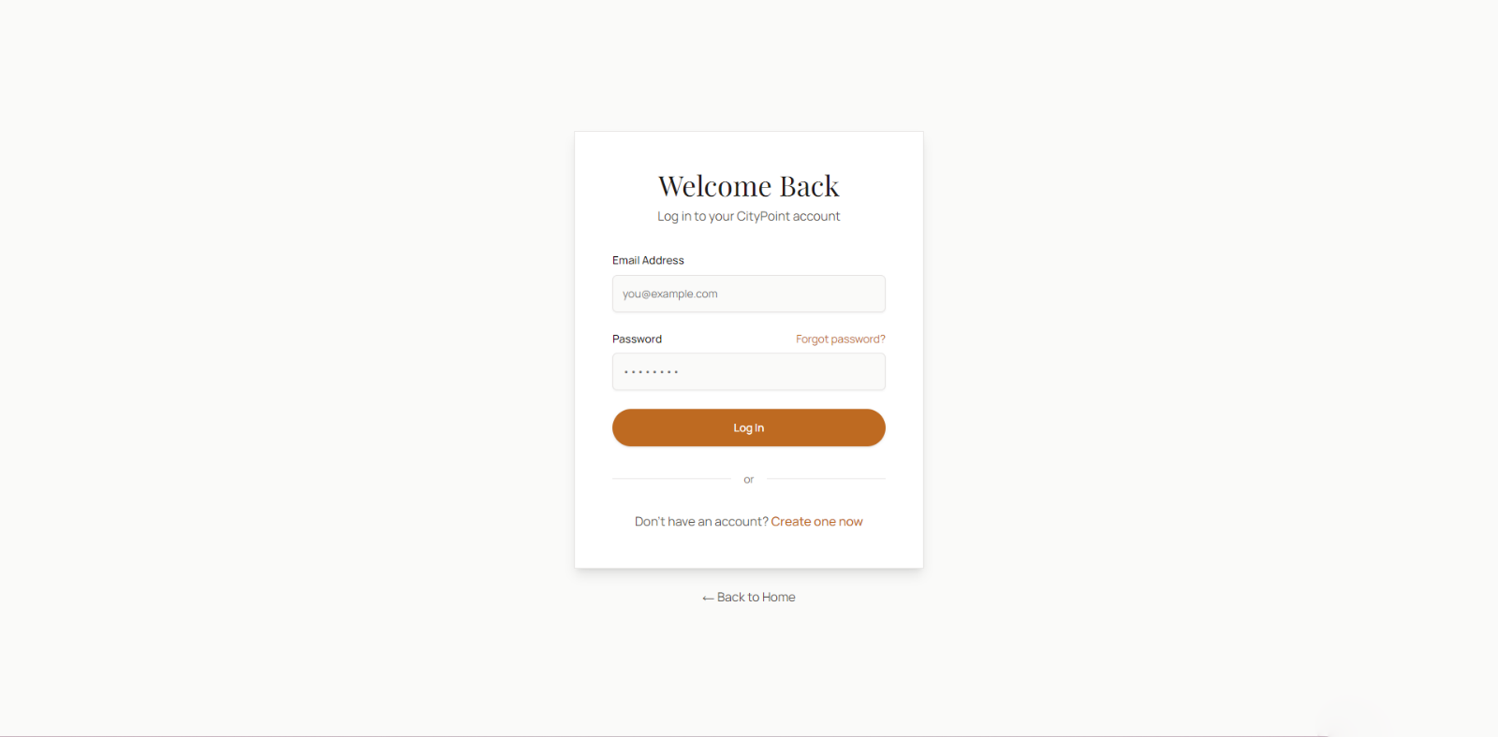

Algorithm Designs (Flowcharts)
  - Logging in
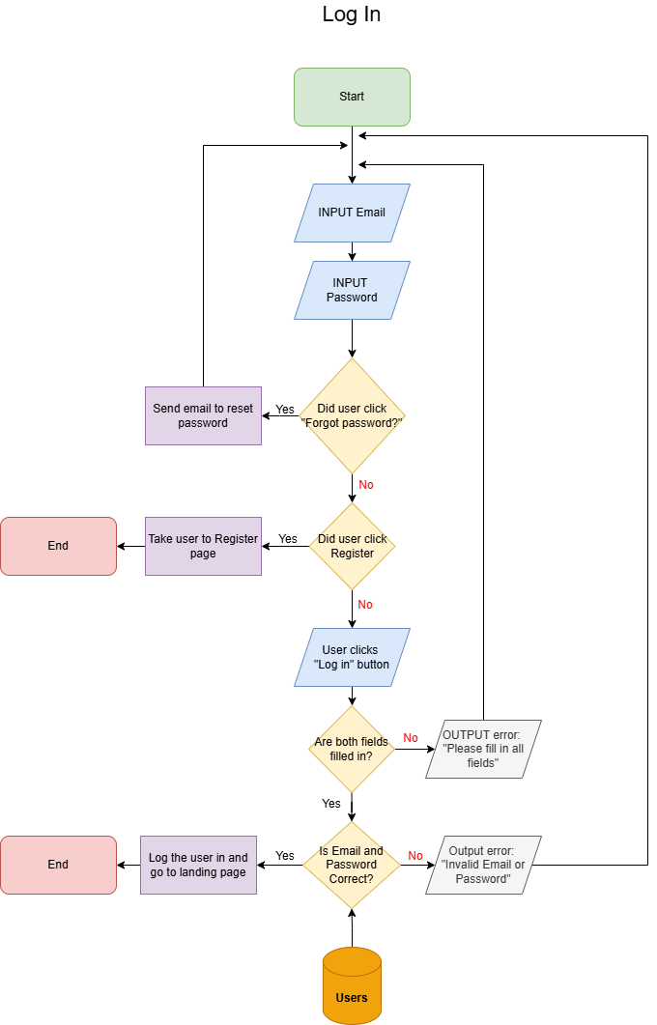
When the user is in the log in page, they will be prompted to input their email and password to each required field. The system will then assess if the user clicked other options such as forgot password or register, if they did it will take the appropriate actions such as sending a reset email link or redirecting the user to the register page. If the user did not choose any other options and filled in the required fields and clicked the log in button, the system will then check if both fields are filled and if the email and password match the ones in the database. If both fields are not filled then an error message is outputted, same thing for the login credentials if they do not match the ones in the database. Lastly if all the steps were correct then the system will successfully log in the user and redirect them to the landing page.

  - Register
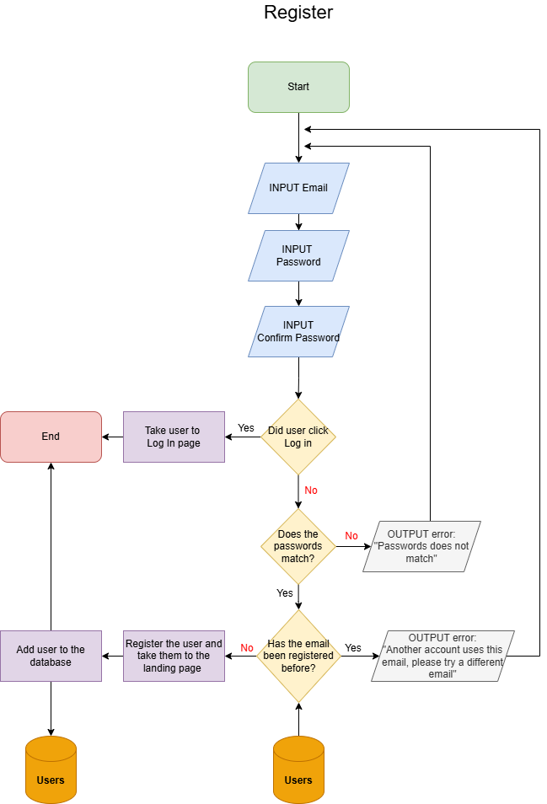

When the user is in the register page the user will be prompted to enter their email and their password twice. The system will then assess if the user clicked other options such as log in, if the user did then the system will redirect the user to the log in page. If the users did not click other options and filled in the required fields then the system will check if the user’s passwords are correct and matches each other. It will also check if the email is unique and has not been registered before to the database, if there are any errors a message will pop up that tells the user what is wrong. If all of these steps are correct the system will then register the user successfully and redirect them to the log in page and add their details to the database.
  - Booking a Room
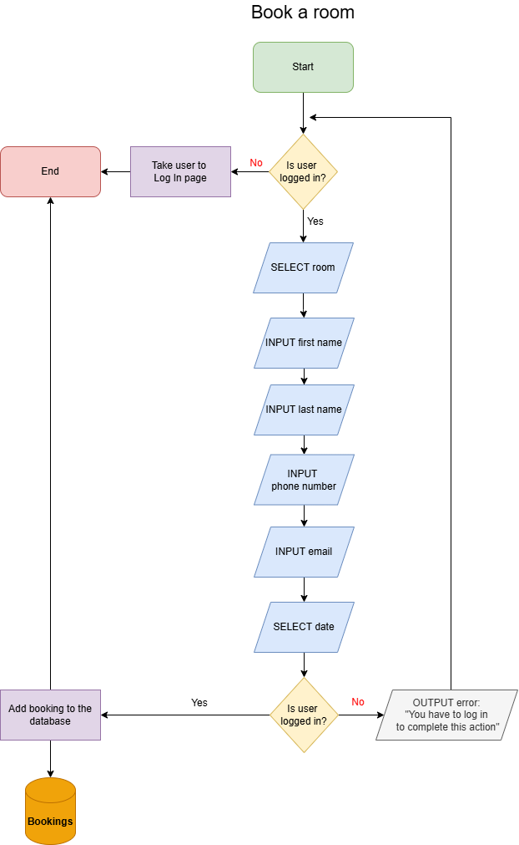

Database Design
  - MVC System Diagrams
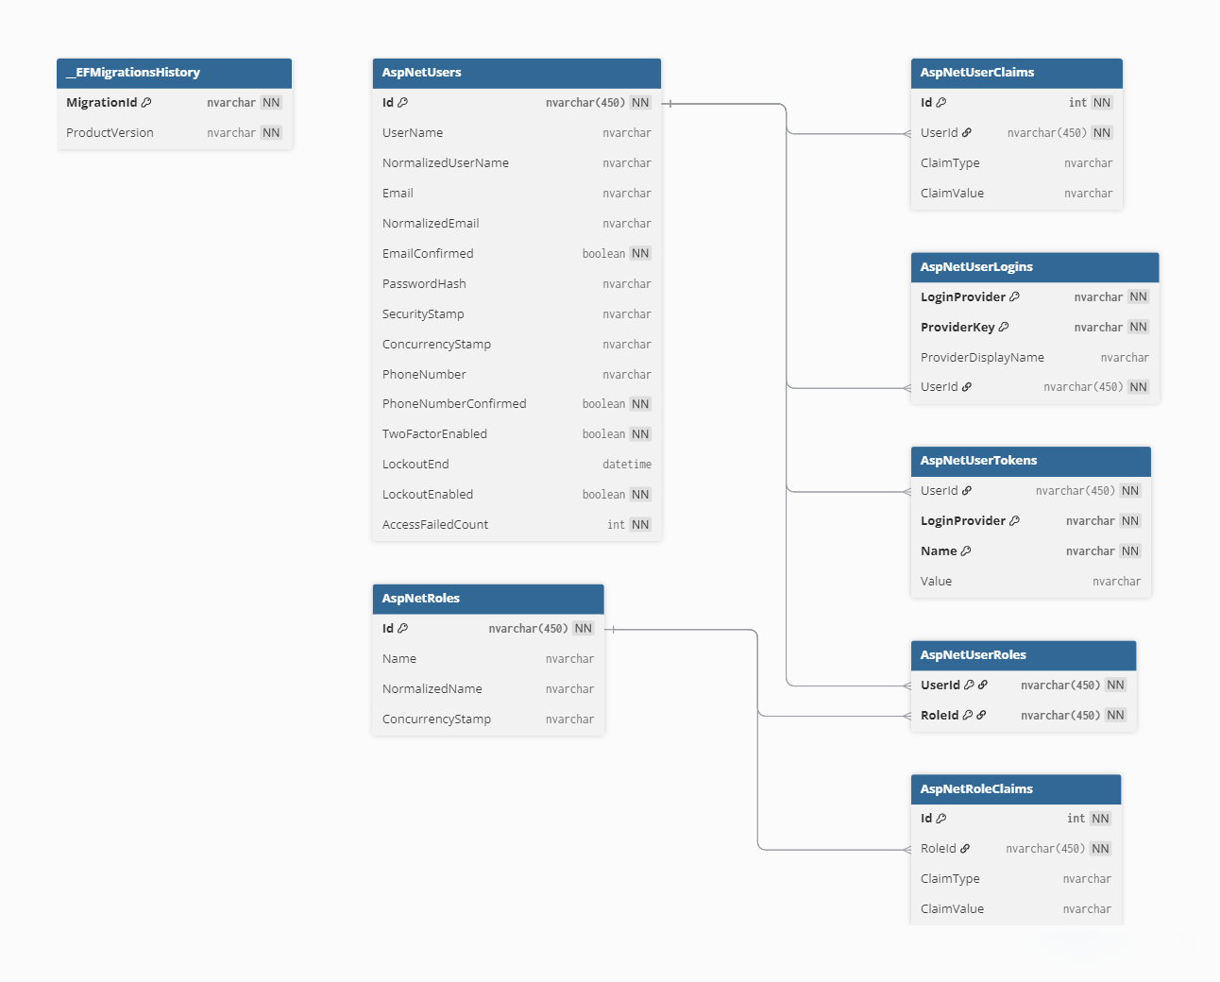

  - CityPoint Room Hire Diagrams
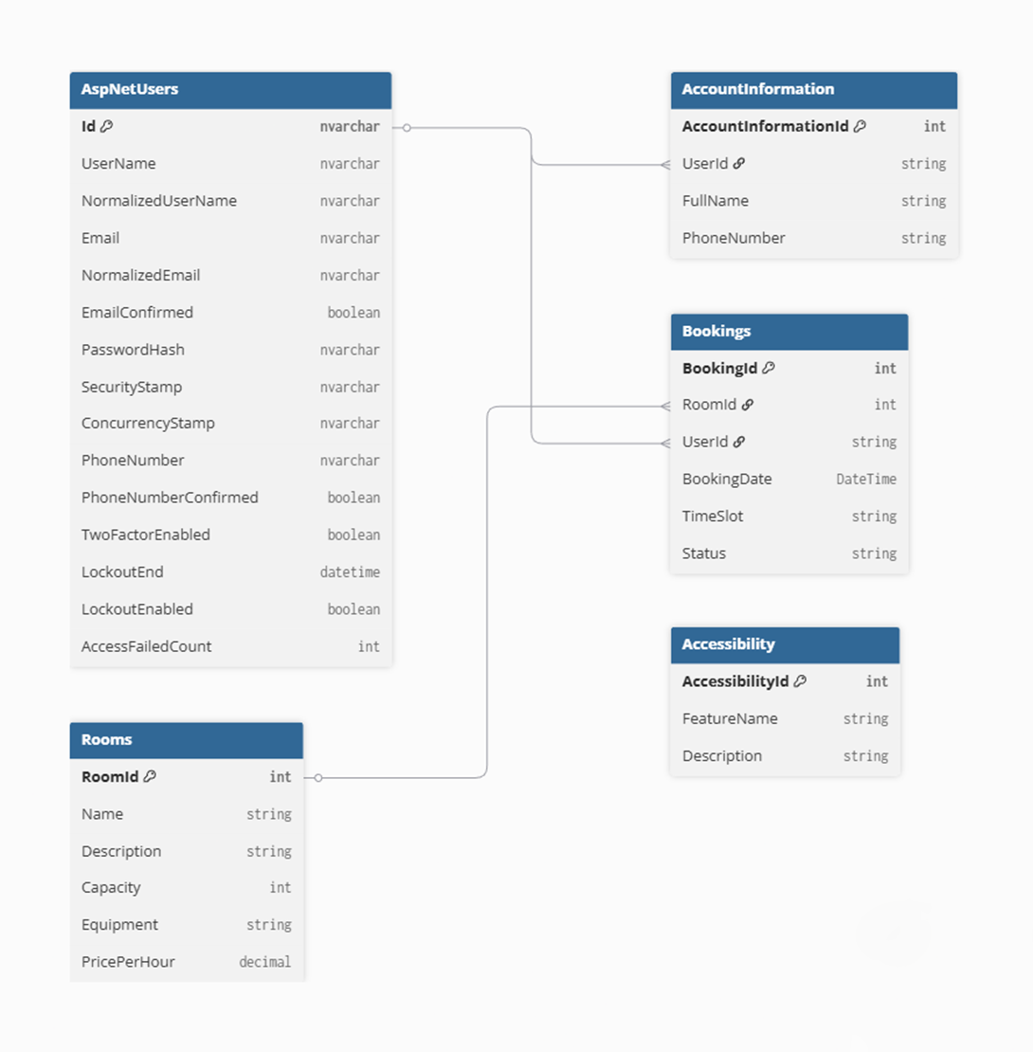

Data Dictionary

MVC System Data Dictionary
  - AspNetUsers
Property | Datatype | Purpose | PK/FK | Size | Required?
Id | nvarchar | Primary identifier for the user | PK | 450 | Yes
UserName | nvarchar | User's username | - | Default | No
NormalizedUserName | nvarchar | Normalized username for lookups | - | Default | No
Email | nvarchar | User's email address | - | Default | No
NormalizedEmail | nvarchar | Normalized email for lookups | - | Default | No
EmailConfirmed | Boolean | Indicates if email is confirmed | - | Default | Yes
PasswordHash | nvarchar | Hashed password | - | Default | No
SecurityStamp | nvarchar | Security stamp for password changes | - | Default | No
ConcurrencyStamp | nvarchar | Concurrency token for optimistic concurrency | - | Default | No
PhoneNumber | nvarchar | User's phone number | - | Default | No
PhoneNumberConfirmed | boolean | Indicates if phone is confirmed | - | Default | Yes
TwoFactorEnabled | boolean | Indicates if 2FA is enabled | - | Default | Yes
LockoutEnd | datetime | DateTime when lockout ends | - | Default | No
LockoutEnabled | boolean | Indicates if lockout is enabled | - | Default | Yes
AccessFailedCount | int | Count of failed access attempts | - | Default | Yes

  - AspNetRoles
Property | Datatype | Purpose | PK/FK | Size | Required?
Id | nvarchar | Primary identifier for the role | PK | 450 | Yes
Name | nvarchar | Role name | - | Default | No
NormalizedName | nvarchar | Normalized role name for lookups | - | Default | No
ConcurrencyStamp | nvarchar | Concurrency token | - | Default | No

  - AspNetUserRoles
Property | Datatype | Purpose | PK/FK | Size | Required?
UserId | nvarchar | Foreign key to AspNetUsers | PK, FK (> AspNetUsers.Id) | 450 | Yes
RoleId | nvarchar | Foreign key to AspNetRoles | PK, FK (> AspNetUsers.Id) | 450 | Yes

  - AspNetUserClaims
Property | Datatype | Purpose | PK/FK | Size | Required?
Id | int | Primary identifier | PK (increment) | Default | Yes
UserId | nvarchar | Foreign key to AspNetUsers | FK (> AspNetUsers.Id) | 450 | Yes
ClaimType | nvarchar | Type of claim | - | Default | No
ClaimValue | nvarchar | Value of claim | - | Default | No

  - AspNetRoleClaims
Property | Datatype | Purpose | PK/FK | Size | Required?
Id | int | Primary identifier | PK (increment) | Default | Yes
RoleId | nvarchar | Foreign key to AspNetRoles | FK (> AspNetUsers.Id) | 450 | Yes
ClaimType | nvarchar | Type of claim | - | Default | No
ClaimValue | nvarchar | Value of claim | - | Default | No

  - AspNetUserLogins
Property | Datatype | Purpose | PK/FK | Size | Required?
LoginProvider | nvarchar | External login provider | PK | Default | Yes
ProviderKey | nvarchar | Key from external provider | PK | Default | Yes
ProviderDisplayName | nvarchar | Display name of provider | - | Default | No
UserId | nvarchar | Foreign key to AspNetUsers | FK (> AspNetUsers.Id) | 450 | Yes

  - AspNetUserTokens
Property | Datatype | Purpose | PK/FK | Size | Required?
UserId | nvarchar | Foreign key to AspNetUsers | FK (> AspNetUsers.Id) | 450 | Yes
LoginProvider | nvarchar | External login provider | PK | Default | Yes
Name | nvarchar | Token name | PK | Default | Yes
Value | nvarchar | Token value | - | Default | No

  - __EFMigrationsHistory
Property | Datatype | Purpose | PK/FK | Size | Required?
MigrationId | nvarchar | Identifier for applied migration | PK | Default | Yes
ProductVersion | nvarchar | EF Core version used | - | Default | Yes

CityPoint Room Hire Data Dictionary
  - Rooms
Propertys | Datatype | Purpose | PK/FK | Size | Required?
RoomId | integer | Primary identifier for a room | PK | Default | Yes
Name | string | Name or label of the room | - | 100 | Yes
Description | string | Description of the room | - | 500 | No
Capacity | integer | Maximum number of people allowed | - | Default | Yes
Equipment | string | Equipment available in the room | - | 250 | No
PricePerHour | decimal | Cost to book the room per hour | - | Default | Yes

  - Bookings
Property | Datatype | Purpose | PK/FK | Size | Required?
BookingsId | Integer | Unique identifier for a booking | PK | Default | Yes
RoomId | Integer | Room being booked | FK | Default | Yes
UserId | string | User who made the booking | FK | 450 | Yes
BookingDate | DateTime | Date of the booking | - | Default | Yes
TimeSlot | string | Time range of the booking | - | 50 | Yes
Status | string | Booking status (Pending, Approved, Cancelled) | - | 50 | Yes

  - AccountInformation
Property | Datatype | Purpose | PK/FK | Size | Required?
AccountInformationId | Integer | Unique identifier for account info | PK | Default | Yes
UserId | string | Linked user account | FK | 450 | Yes
FullName | string | User’s full name | - | 150 | Yes
PhoneNumber | string | User’s contact phone number | - | 50 | Yes

  - Accessibility
Property | Datatype | Purpose | PK/FK | Size | Required?
AccessibilityId | Integer | Unique identifier for accessibility feature | PK | Default | Yes
FeatureName | string | Name of accessibility feature | FK | 100 | Yes
Description | string | Description of the accessibility feature | FK | 250 | No

